Parent FAQ’s and Information

- How long is a wrestling match?
  - A wrestling match is made up of three (3) two-minute periods. If the score is tied at the end of the match, an overtime period(s) are wrestled.
- Why do the team members wear red and green straps on their ankles when they wrestle, and why do the referees wear read and green bands on their wrists?
  - The green band denotes the home team and the red is the visiting team. The referee raises the arm with the green arm band when awarding points, issuing cautions or assessing penalties to the home team. The same procedure is used for the visiting team.
- How is the question of who wrestles at what level and weight determined?
  - Coaches will decide which wrestlers will wrestle varsity and junior varsity based on a number of criteria including, but not limited to: wrestle offs, previous performance, performance in the practice room, weight and weight class considerations and finally, what is best for the team.
- Why does the team participate in so many tournaments?
  - The team participates in tournaments to gain experience. Sometimes the wrestlers will refer to this as "mat time". It is very important that the younger wrestlers get as much mat time as possible. This enables them to hone their skills.
- Why are there two (2) sets of scores on the scoreboard? What are the other numbers on the board?
  - The team score, individual score, period clock, weight class and the number of periods can all be found on the scoreboard.
- How are individual scores determined?
  - Individual scores are determined by the types of moves that are executed during the match.
Takedown: Two (2) points.
Escape: One (1) point.
Reversal: Two (2) points.
Near Fall: Two (2) or three (3) points, depending on the time the wrestler is on his back.
Penalty: One (1) or two (2) points, depending on the number of penalties issued up to that point.

- How are team scores determined?
  - Team scores are determined by the type of victory each individual on the team has made.
Decision (1-7 point spread): Three (3) points.
Major decision (8-14 point spread): Four (4) points.
Technical Fall (15 point spread): Five (5) points.
Pin: Six (6) points.
Forfeit: Six (6) points
- Why do referees get tagged with a rolled up towel or flexible tube?
  - When several mats are in the same gymnasium, the buzzers cannot be used to let the referee know when the match periods are over. To allow the referee to watch the match instead of the timekeeper, the referee is tagged when time has run out.
- Why do referees stop the match when the wrestlers seem to be actively wrestling?
  - The referee can stop the match when the hold that is being used could be injurious to one of the wrestlers (dangerous hold) or if neither wrestler is making any progress with the hold they are using (stalemate) or it is the end of the period.
- After a referee has stopped the match, why do the boys sometimes start in a neutral position (facing each other) and other times in an up-down position (one boy is given the advantage of the top position while the other is kneeling)?
  - The first period always starts with the wrestlers in the neutral position. The second period position is determined by the choice of one of the wrestlers, which is determined by a toss by the referee of a (usually) green on one side and red on the other flat object. The choice going to the wrestler wearing the ankle band matching the color of the flat object which lands face up. The third period is given to the other wrestler. Their choices are: deferring to the other wrestler (this can only happen at the start of the 2nd period), top, bottom or neutral.

- What are the weight classes for wrestling?
  - The 14 weight classes are as follows: 106, 113, 120, 126, 132, 138, 145, 152, 160, 170, 182, 195, 220, 285.
  - JV/Junior high wrestlers are often matched up by close proximity weight usually within 5-10lbs.
- Who are the people sitting at the tables in the gymnasium?
  - An official scorekeeper and a timekeeper will always be at the table. You may also find an announcer and team scorekeeper.

WRESTLING TERMINOLOGY

Caution: A ruling made by the referee where one wrestler is called for stalling, a false start, wrong starting position, etc. A second offense is a penalty. See: Stalling, Warning.

Control: A position of advantage where one wrestler maintains restraining power over the other. This usually means that the other wrestler is off his feet and on the mat.

Cradle: A pinning situation where the offensive wrestler has his opponent's head and one of his legs encircled, usually with his arms. In a pinning situation, locking of the hands is legal.

Escape: When the defensive wrestler gains a neutral position and his opponent has lost control while either wrestler is inbounds. Counts one (1) point.

Fall: Also called a "Pin." When either both shoulders or both shoulder blades are held in contact with the mat for two (2) continuous seconds. It terminates the match and is worth six (6) team points.

Leg Bands: In tournaments, the contestants wear leg bands to identify which one is being scored as the home wrestler and which is the away wrestler. The green leg band is for home, the red for away. Scoring cards, when used, are also green and red. The referee's coin is green on one side and red on the other. It is used to determine which wrestler chooses the starting position at the beginning of the second period.

Locking Hands: Interlocking or overlapping hands, arms or fingers around the opponent's body is illegal, except when both wrestlers are on their feet or in a pinning (near fall) situation.
Match: Individual contest between two wrestlers.
Meet: A contest between two wrestling teams. Each team may have one wrestler in each weight class. Team points are awarded on the basis of the results of individual matches between wrestlers. See: Points (Team), Tournaments.

Near Fall: A near fall occurs when the offensive wrestler has control of his opponent in a pinning situation. It involves holding the shoulders or shoulder blades within four (4) inches of the mat or holding one (1) shoulder or shoulder blade on the mat and the other is held at a 45-degree angle for two (2) seconds. It is awarded when the defensive wrestler gets out of the pinning situation. A nearfall is two (2) points if held for two (2) to four (4) seconds or three (3) points if held for five (5) seconds.
Neutral Position: A position where neither wrestler has control. See: Control.
Pin: See: Fall.
Points (Match): Awarded for a takedown (2 points), escape (1 point), reversal (2 points), and near fall (2 or 3 points). Penalty points are awarded for warnings. See: Warnings.
Points (Team): Awarded on the basis of individual matches. A fall (or pin), forfeit, default or disqualification is six (6) points. A technical fall is five (5) points. A major decision (point spread of 8 to 14 match points) is four (4) points. A decision (point spread of 1 to 7 match points) is three (3) points. See: Tournament.
Referee's Starting Position: A starting position where one wrestler is in a defensive position (on hands and knees) and the other is in an offensive position (positioned over the other, normally with at least one knee on the mat).
Reversal: When the defensive wrestler comes from underneath and gains control over his opponent either on the mat or in a near-standing position, while either wrestler is inbounds. Counts two (2) points.
Stalling: A caution by the referee when one of the wrestlers fails to make a reasonable effort to wrestle aggressively. An offensive wrestler must make a reasonable effort to pin his opponent; a defensive wrestler, to escape.
Starting Position: The wrestlers begin each period either in the neutral or referee's position. The first period always starts in the neutral position. For the second period, a coin toss decides which wrestler chooses the starting position. He elects the neutral, offensive or defensive position, or he may defer his choice. Unless he defers, the other wrestler chooses the starting position for the third period. When the wrestlers go out of bounds, either the neutral or referee's starting position is used, depending on whether one wrestler has control.
Takedown: When one wrestler gains control over the other down on the mat from a neutral position while either wrestler is inbounds. A takedown is normally awarded when one or both of the defensive wrestler's knees are down on the mat. Counts two (2) points.
Technical Fall: It occurs when one wrestler has accumulated fifteen (15) points more than his opponent. It terminates the match and is worth five (5) team points.

Tournament: A contest between several schools where wrestlers are divided into weight brackets. Each school may have one or more wrestlers per bracket. Normally, wrestlers in each bracket are seeded according to past records. Team points are given on the basis of the final placement of its wrestlers. See: Leg Bands.

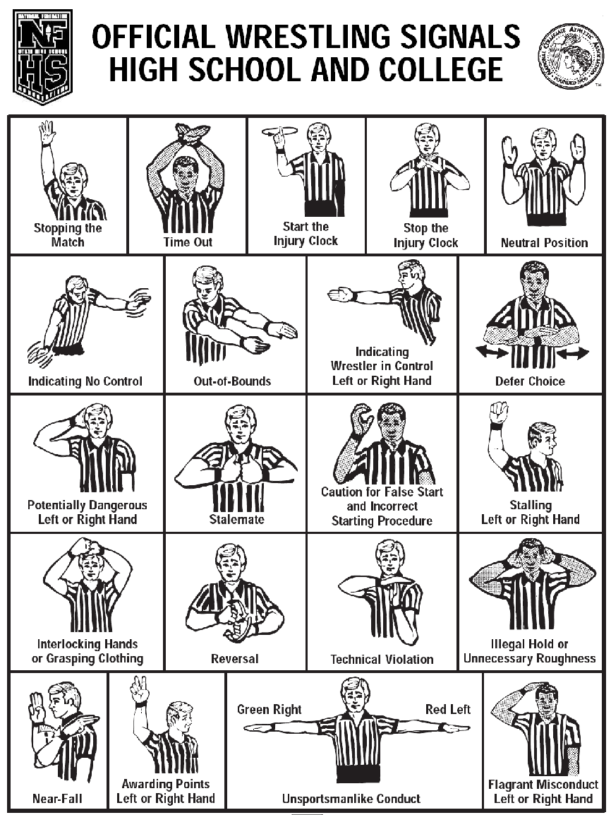

METHODS OF WEIGHT CONTROL THAT SHOULD BE AVOIDED

Dehydration: Weight loss in wrestlers usually occurs in a short period of time and consists primarily of water loss. If you lose weight faster than 2-3 pounds per week, you are likely losing water (and perhaps muscle tissue). Unfortunately, when you rehydrate after weigh-in, your body absorbs water at a relatively slow rate: about 2 pints per hour and it takes up to 48 hours for the water balance to be restored. The ill effects of dehydration include a decrease in muscular strength and endurance, a decrease in blood flow to muscle tissues, and an impaired ability to properly regulate your body temperature. Therefore it is recommended that:

- Wrestlers should limit weight loss by dehydration to a bare minimum.
- Use of diuretic drugs ("water pills") to help lose water weight should be avoided. These drugs can cause disorders in the way your heart and kidneys function.
- Wrestlers should not rely upon sitting in a steam room or sauna to cut weight. Exercise in a plastic suit should also be avoided and is illegal. These practices are strongly discouraged because they can cause rapid dehydration and heat stroke, which may be fatal.

Fasting: When you do not eat at all (fasting), your body uses its stored nutrients, and weight loss
will certainly result. However, fasting quickly reduces your blood sugar, which in turn robs your brain and muscles of their most important energy source. Fasting can cause your muscles to use muscle proteins for energy, even if fat is available. Eat at least the minimum calories your body requires each day so you can maintain your energy and strength while losing weight.

Yo-Yo Dieting: The greater the peaks and valleys in your body weight, the more difficult it is for your body to function correctly. Studies have shown that alternating between feast and famine may cause your body to use food more efficiently (hanging on more tightly to each calorie). Yo-Yo dieting just makes cutting weight more difficult.

Diet Pills: Using diuretics (water pills) and laxatives to lose weight will dehydrate your body and rob your body of important nutrients. Diet pills can cause many adverse physical, as well as psychological, effects.

Research has shown that practicing proper methods of weight control are essential to maximizing your athletic performance. Peak physical performance can only occur when the body is supplied with an adequate amount of essential nutrients. Using improper methods of weight control will decrease your level of performance.

The psychological advantages of maintaining good nutritional practices are great. You'll wrestle better if you feel good physically and mentally. You will also wrestle better knowing that you have done everything possible to be at your best.

THE WRESTLER'S DIET

Wrestlers who cut weight often deny themselves the very nutrients they need to perform well. Many wrestlers either don't care about proper nutrition or they simply do not know any better. Wrestlers often think of food and water only in terms of gaining weight. They forget that food provides nutrients to fuel their bodies. However, the scientific facts are simple - poor nutrition will hamper performance. The body cannot function at its best when it lacks vital nutrients. Consider these points:

- Concentrating on wrestling rather than on cutting weight will make you a better wrestler.
- To grow naturally and increase strength, wrestlers need the same nutrients as other teenagers but need more calories to meet the demands of daily training.
- Fasting causes the body to use muscle proteins for energy even if fat is available. This limits muscle growth and strength development.
- A proper diet will help wrestlers lose fat weight without sacrificing muscle tissue or becoming dehydrated.
- Dehydration is a major cause of losses in strength and endurance.
- Losing weight rapidly results in a loss of both muscle tissue and water.
- Losing weight gradually (2-3 lbs/week) is the best way to lose fat and keep muscle.
- Proper training includes practicing proper nutrition every day.
- Practicing good nutrition and proper weight control methods is vital to achieving peak physical performance.

There are several factors to consider when deciding your "best" wrestling weight, but the most important is how much weight can you safely lose and still perform well? The weight class you choose should not be so low that you have to sacrifice good nutrition for the sake of making weight. In addition to the adverse physical effects of trying to cut too much weight, unhealthy weight loss practices affect you psychologically. The more you worry about your weight, the less you concentrate on your wrestling.

NUTRIENTS

Your body depends upon a constant supply of nutrients to keep it functioning. There are six essential groups of nutrients your body needs every day: water, carbohydrates, protein, fats, vitamins, and minerals.

Water: The most important nutrient for any athlete is water. Your body is 60-70% water. Water is absolutely essential for optimal health and peak performance. You may be surprised to know that dehydration is a major cause of decreased performance. Some wrestlers are more sensitive to dehydration than others. A fluid loss of 2-3% of your weight can quickly occur during intense training. Even modest levels of dehydration should be avoided because it harms performance. It is important to drink plenty of fluids during practice and between matches. Not only will you feel better, but you may also find you have more endurance. During physical activity, thirst is not an adequate signal of the need for fluid. Follow the fluid guidelines listed below:
- Weigh-in before and after training to monitor fluid loss. Drink two cups of fluid for every pound of body weight lost.
- Drink 2 ½ cups of fluid two (2) hours before training or competition.
- Drink 2 ½ cups of fluid fifteen (15) minutes before competition.
- Drink 1 cup of fluid every 15-20 minutes during training and competition.
- Avoid beverages containing alcohol and caffeine, as they promote dehydration.

Carbohydrates: Carbohydrates are the main food source for your body and should make up 55-
65% of the total calories you consume. Excellent sources of carbohydrates include breads, pasta, cereals, fruits, and vegetables.
Fat: Everyone needs a little fat in their diets, and wrestlers are no exception. Fat should make
up about 20-30% of the calories you consume. Most of the fat we consume is naturally found in foods (meats, nuts, and dairy products) or added during the preparation of food (e.g. fried foods). Sources of additional fat include margarine, peanut butter, and salad dressings.
Protein: Protein is used for growth and repair of all the cells in your body. Good sources of protein are meat, fish, and poultry. Many plant foods like beans and nuts are good protein sources, too. However, nuts are also high in fat and should be eaten only in small quantities. Your diet should provide 12-15% of its calories as protein. The typical American diet provides more than enough protein, so you don’t need to worry too much about your protein intake.
Vitamins and Minerals: If you eat a balanced diet from the basic food groups, you will consume most of the vitamins and minerals your body needs, however, specific supplementation may be advanced for certain athletes.

